Theory of Algorithms
Student name
University affiliated

Answer1
a)
Density = (7*2)/ (4*5)
= 14/20
=0.7
Where;
|v| = vertices number in the graph
|E|= number of edges represented in the graph
b)
According to the number of edges, the diagram is a simple undirected graph.
c)
This is the adjacent matrix of the graph
 | 0 | 1 | 2 | 3 | 4
0 | 1 | 1 | 0 | 1 | 1
1 | 1 | 1 | 1 | 1 | 0
2 | 0 | 1 | 1 | 1 | 0
3 | 1 | 1 | 1 | 1 | 1
4 | 1 | 0 | 0 | 1 | 1

d)
Kruskal’s algorithm
It is an algorithm where we first select the weight that is minimum, and then we maintain rising the weight. Therefore, it shouldn’t be in a circular manner. It begins with a tilt of lines and then it is fixed in a non-decreasing order.
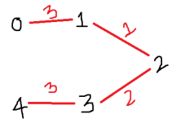

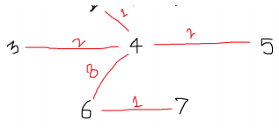

Answer2

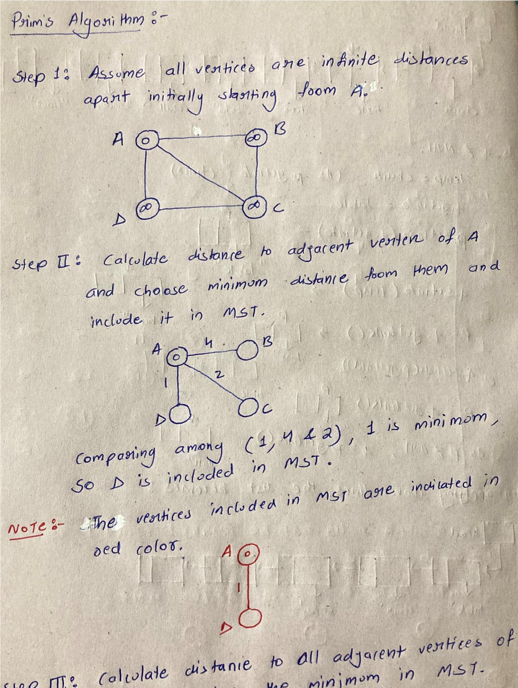

Textbook Solutions
Expert Q&A
Practice
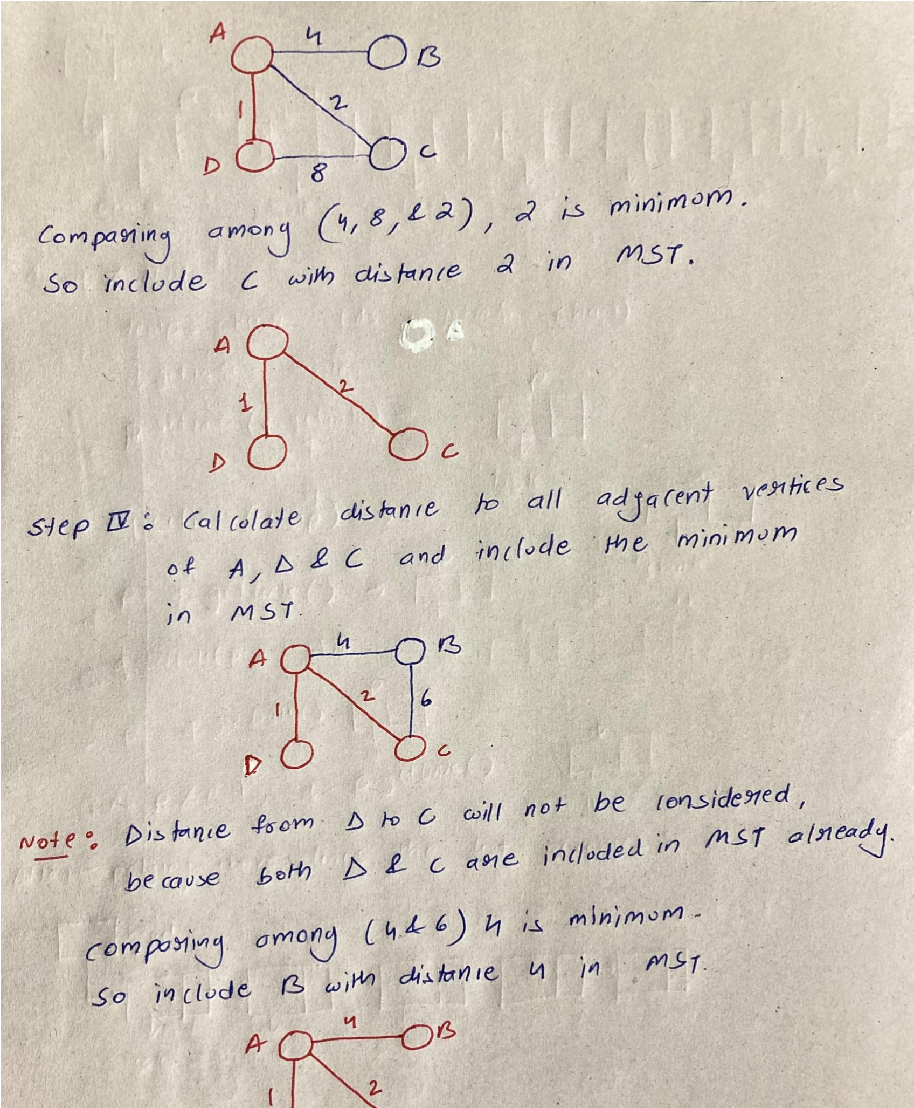

Answer3
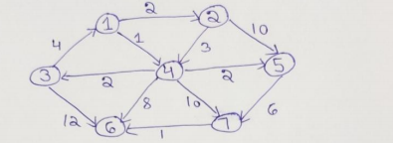

The below calculations show how to get the shortest distance
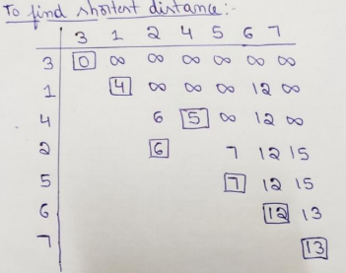

The shortest paths starting from vertex 3 includes;
- 3 to 1 i.e. 3-1
- 3 to 2; that is from 3 to 1 then to 2
- 3 to 5 i.e. from 3, to 1, to 4, to 5
- 3 to 6 that is from 3 the to 6 direct.
- 3 to 7 that is from 3-1-4-5-7
Answer4
#include <iostream>
#include <climits>
#include <vector>
using namespace std;
#define V < 11
bool createsMST(int u, int v, vector<bool> inMST){
if (u == v)
return false;
if (inMST[u] == false && inMST[v] == false)
return false;
else if (inMST[u] == true && inMST[v] == true)
return false;
return true;
}
void printMinSpanningTree(int cost[][V]){
vector<bool> inMST(V, false);
inMST[0] = true;
int edgeNo = 0, MSTcost = 0;
while (edgeNo < V - 1) {
int min = INT_MAX, a = -1, b = -1;
for (int i = 0; i < V; i++) {
for (int j = 0; j < V; j++) {
if (cost[i][j] < min) {
if (createsMST(i, j, inMST)) {
min = cost[i][j];
a = i;
b = j;
}
}
}
}
if (a != -1 && b != -1) {
cout<<"Edge "<<edgeNo++<<" : ("<<a<<" , "<<b<<" ) : cost = "<<min<<endl;
MSTcost += min;
inMST[b] = inMST[a] = true;
}
}
cout<<"Cost of Minimum spanning tree ="<<MSTcost;
}
int main() {
int cost[][V] = {
{ INT_MAX, 12, INT_MAX, 25, INT_MAX },
{ 12, INT_MAX, 11, 8, 12 },
{ INT_MAX, 11, INT_MAX, INT_MAX, 17 },
{ 25, 8, INT_MAX, INT_MAX, 15 },
{ INT_MAX, 12, 17, 15, INT_MAX },
};
cout<<"The Minimum spanning tree for the given tree is :\n";
printMinSpanningTree(cost);
return 0;
}

References
Machtey, M., & Young, P. (2017). An introduction to the general theory of algorithms. North Holland.
Markov, A. A. (2017). Theory of algorithms.
Thulasiraman, K., & Swamy, M. N. (2019). Graphs: Theory and algorithms. John Wiley & Sons.

